86.07.03
From Daniel Oliver
RB MSS M1, Library, Royal Botanic Gardens Melbourne.

3 July 86
Dear Sir Ferdinand
The Hull Botanic Garden sends a fragment of what seems to me a new Swainsona (unless a species described by you since the "Flora Australiensis".
From the single dark flower & leaf enclosed is it possible for you to venture an opinion? The raceme is several-flowered, lax overtopping the leaf, ovary stipitate: ovules c. 8; Callus ([…]) 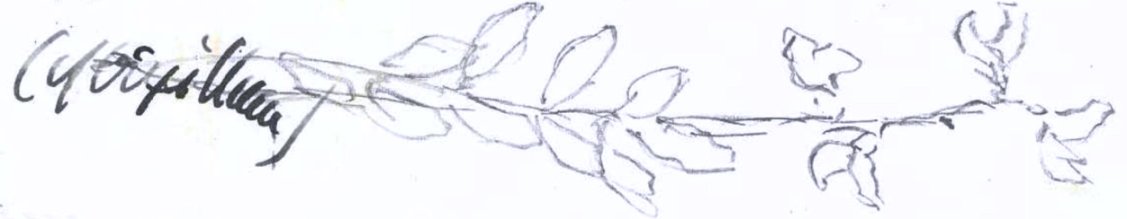
[0.]

It is too bad to trouble you with such a miserable scrap — but there is a chance you may know it.
Ever respectfully Yours
D. Oliver.

Swainsona

MS bears the letterhead: 'Royal Gardens Kew'. MS annotation by M: 'Answ 17/8/86 FvM'; see M to D. Oliver, 16 August 1886.
Bentham (1863-78)
The left end of a pencil sketch inserted here is partially covered by the illegible word: 86-07-03_image01.jpg.
MS bears the stain of the small specimen included.

